If you’re reading this, you have been shortlisted for Final Round - Assignment Round. The following will be your assignment tasks.

**Assignment Details:**

Objective: Replicate a single page from 2 websites we'll provide.

Skills Tested: HTML, CSS, and JavaScript.

This task will give us an insight into your ability to create responsive, clean, and efficient web pages. Your attention to detail, code quality, and ability to reproduce the design and functionality will be important metrics for evaluation.

**Instructions**:

1.We will send you the URLs of the two web pages you need to replicate.

2.Replicate the design and functionality as closely as possible. If there are interactive elements or animations on the page, please include them in your replication.

3.Host the replicated pages on a platform of your choice (e.g., GitHub Pages, Netlify, etc.) and provide us with the links.

4.Along with the hosted pages, please share the source code repository or a ZIP file containing all your code.

**WEBISTE 1**

You need to replicate the below page with all the animations that is added in the page

<https://www.codigo.co/services>

While hovering over the below image, you can see the animation. The animation image is also attached below.

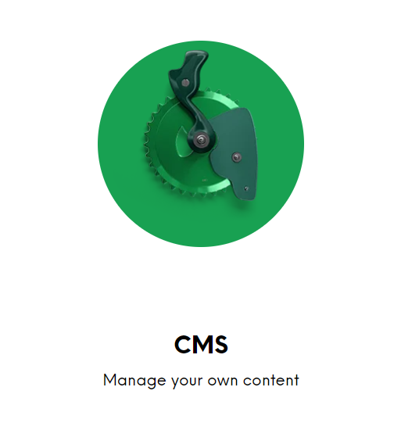

Animation will be something like this after hovering.  
  
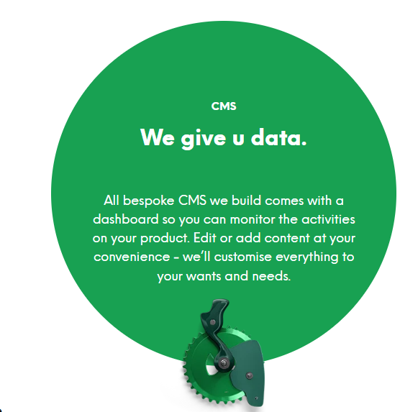

**WEBISTE 2**

<https://primefort.net/contact>

You need to replicate the above page as it is.  
Use the same contents that is there in the webpage.

ASSIGNMENT SUBMISSION

1. Zip file of the source code
2. Hosted links of the 2 pages

You need to email the above 2 things to - assignments.creatorslab@gmail.com

Deadline: 08/10/2023 (within 11 pm )